**Coding Instructions Word Length Effect**

To start looking at your data, you will first have to download them from Qualtrics. First, navigate to the folder for your section and to your experiment. In Qualtrics, click on “data and analysis” on the top left of the screen.

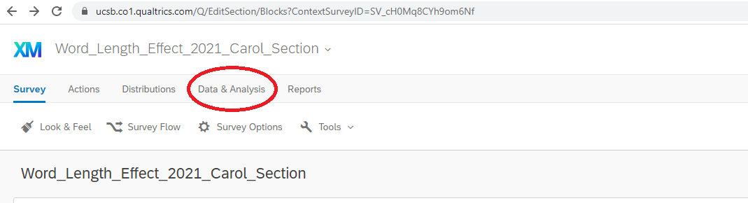

Then click on Export & Import on the top right of the page, select Export and when prompted for a type of file, select Excel and choose “use numeric values”

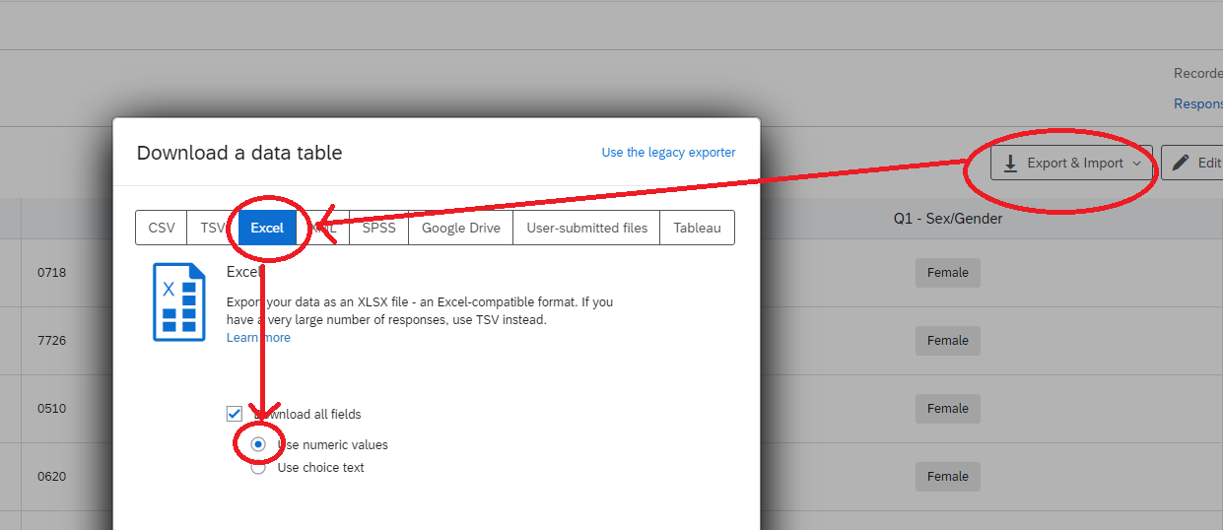

Download and open your Excel file. In this file, each row represents a participant and each column represents a variable. There are many variables in this file that you will not need. The columns that you will need to look at are AW, BZ, DC and EF.

AW lists the words recalled on the first list of short words

BS lists the words recalled on the second list of short words

DC lists the words recalled on the first list of long words

BS lists the words recalled on the second list of long words

You will have to score how many words each subject correctly recalled for each of these lists.

Then you will need to compute the mean number of words that each participant correctly recalled in the short word condition (averaging over the two lists of short words) and how many they correctly recalled in long word condition (averaging over the two lists of long words). You may also need to do some data cleaning (e.g., deleting incomplete data from when people were just testing the program) as instructed in your lab section.

For analysis, you will need to format your data as follows: There will be **3 columns** in your data file, the first one is for the subject ID, the second for the condition, and the third for the number of words correctly recalled in that condition. Because you are comparing 2 conditions, there will be **2 lines** in the file for each participant. For example in the sample below, subject 4106 recalled 5 words in the short words condition and 3.5 words in the long word condition. You will need to fill out this table for all of your subjects.

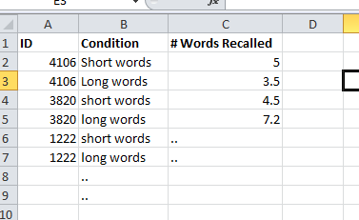

Then follow the instructions you were given in Lab about how to compute your Means, Standard Deviation, Standard Error and your t-test in R.